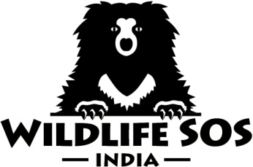

D-210, Defence Colony, New Delhi-110024
Ph. +91 11 46601096/ 24644231
Fax +91 11 41550480
E-mail: volunteer@wildlifesos.org
www.wildlifesos.org

Volunteering Program Application Form

Name:
Date of Birth:
Gender:
Occupation: Please Affix Photograph Above
Educational Qualification:
Nationality:
E-mail ID:
Contact Number:
Blood Group:
Medical Allergies if any:
Food Allergies if any:
Existing Medical Conditions:
Expected Period of Volunteering:
Total No of Days:
Meal Preference: Vegan/Vegetarian
Previous experience with Wildlife:
Preferred Animal to Work With: Sloth Bears/Elephants

Please scan and attach a (Government Approved Photo ID Copy For Indians only), Indian Visa Copy, Passport Copy, Overseas Medical Insurance Copy, Confirmed Flight ticket copy and send it to volunteer@wildlifesos.org
Thank you!

